**Stakeholder Analysis**

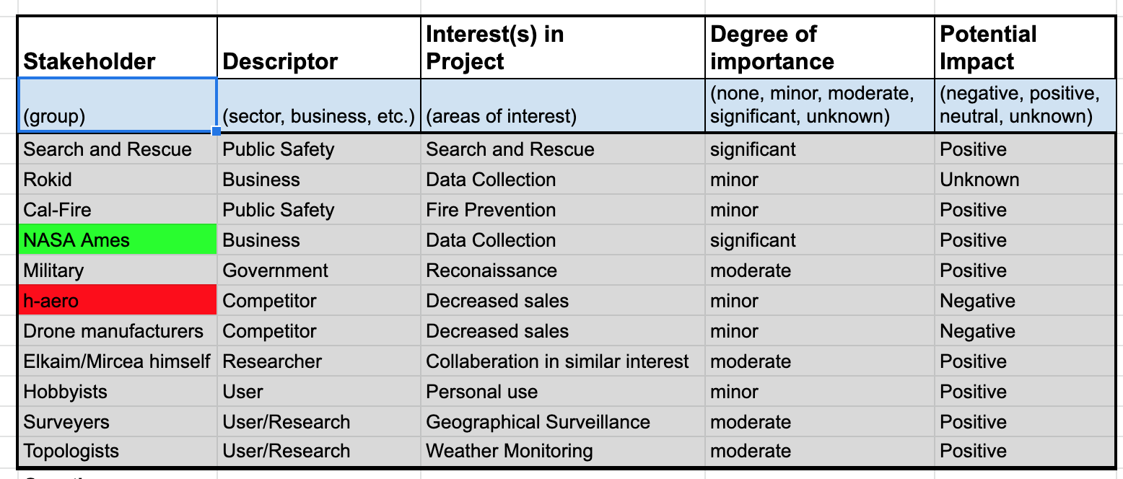

Questions for each stakeholder:

* Purpose of the project?
* What is the price range desired for the product in order to be feasible?
* How long does the drone need to last? Does it need physical durability from potential interactions?
* What are the weather conditions the drone needs to operate under?
* Flight range of the drone?
* Environment the drone will fly in?
* Flight time of the drone?

**Stakeholder Map**

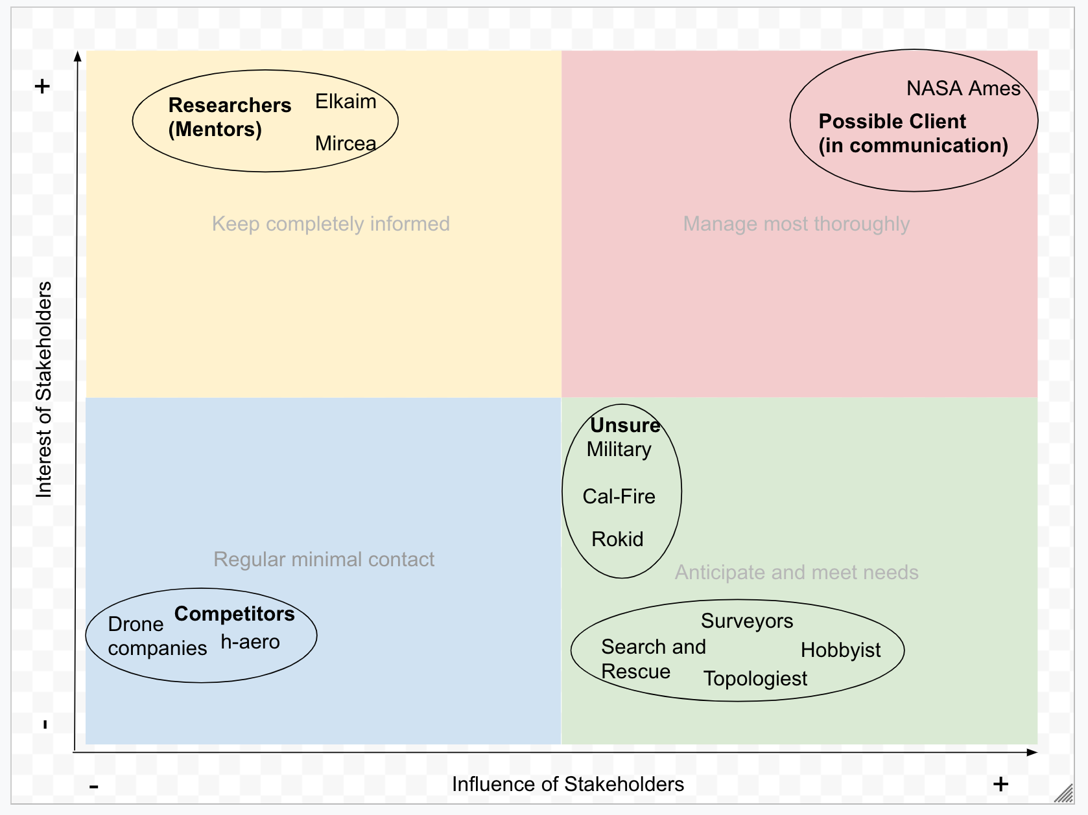

Plan:

* Client (NASA Ames) will provide the majority of answers to our questions, related to the specific needs of the drone. Researchers like Elkaim and Mircea can also answer more specific questions about the engineering process in creating the drone.
* The motive for communication with the client is to ensure the product we are delivering is meeting the clients needs and expectations. The motive for communication with Elkaim and Mircea is to further our understanding of the topics we are less knowledgeable of.
* Contact with client on a weekly/Biweekly basis. Contact Elkaim and Mircea as needed. The most critical stages for client input would be when the project is first started, at the end of the functional design phase, and at the end of the detailed design phase. We want to make sure that their requirements are matching up with the designs that we are creating. This requires that they give us critical feedback, and helpful input from the client at each stage of the design process.
* Client will have a two-way discussion with our team and they will also be an end user. They will provide us with specific goals and feedback for our design. Elkaim and Mircea will have a one way interaction as a mentor to our group, providing us with knowledge in areas where we may lack.
* Interactions with stakeholders would include showing them our block diagram design (e.g. design method and procedure). Interview prompts will be prepared before every stakeholder meeting. During meetings we will take notes and have consensual recordings.